Choix Tech Diagramme/Index

INDEX TIOBE

L'**index TIOBE** mesure la popularité des langages de programmation en se basant sur le nombre de pages web retournées par les principaux moteurs de recherche lorsqu'on leur soumet le nom du langage de programmation[1](https://fr.wikipedia.org/wiki/Index_TIOBE#cite_note-pd-1). Il est mis à jour une fois par mois et donne l'historique depuis 2002. Le langage ayant la plus forte croissance dans l'année est nommé « langage de l'année ».

L'index TIOBE est issu de l'entreprise TIOBE Software BV basée aux Pays-Bas, à Eindhoven.

Règle de l’index : https://www.tiobe.com/tiobe-index/programming-languages-definition/

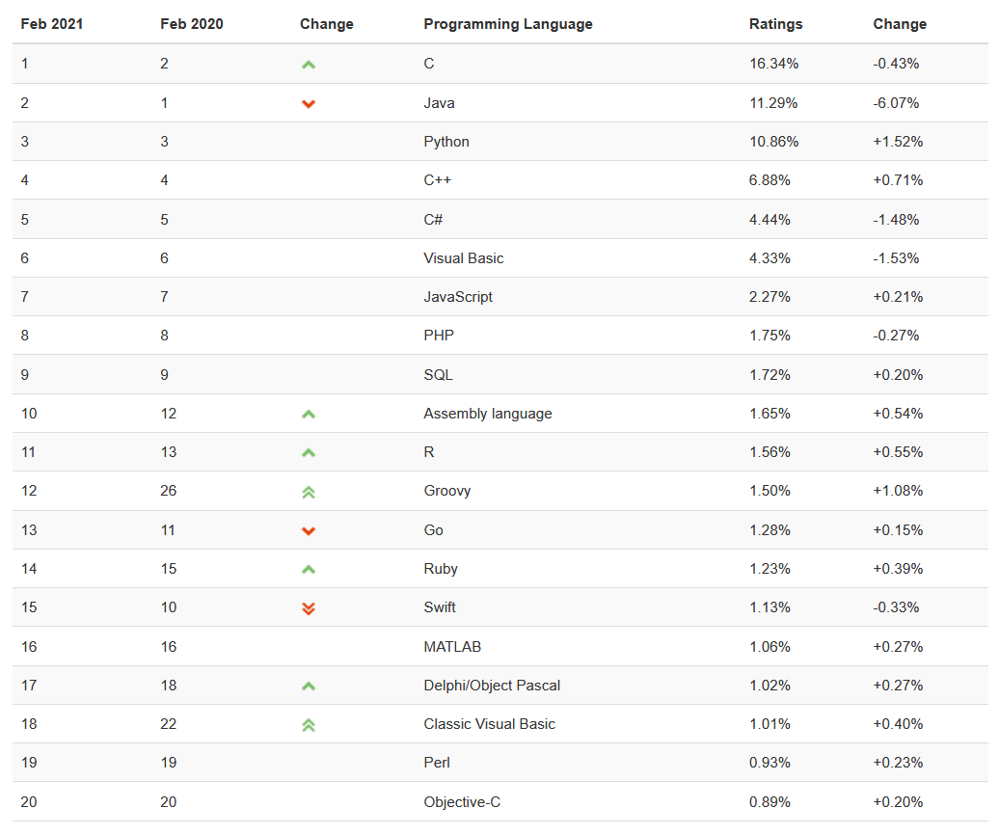

Index TIOBE 02/2021 (<https://www.tiobe.com/tiobe-index/>)

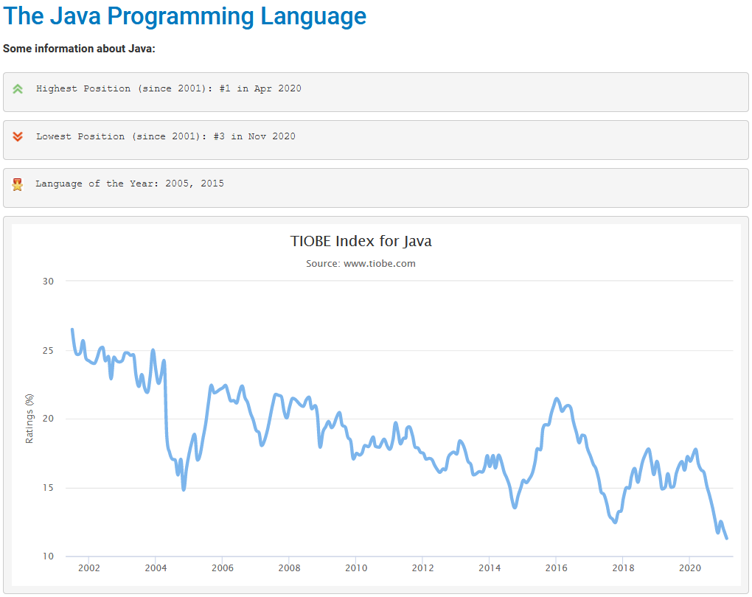

<https://www.tiobe.com/tiobe-index/java/>

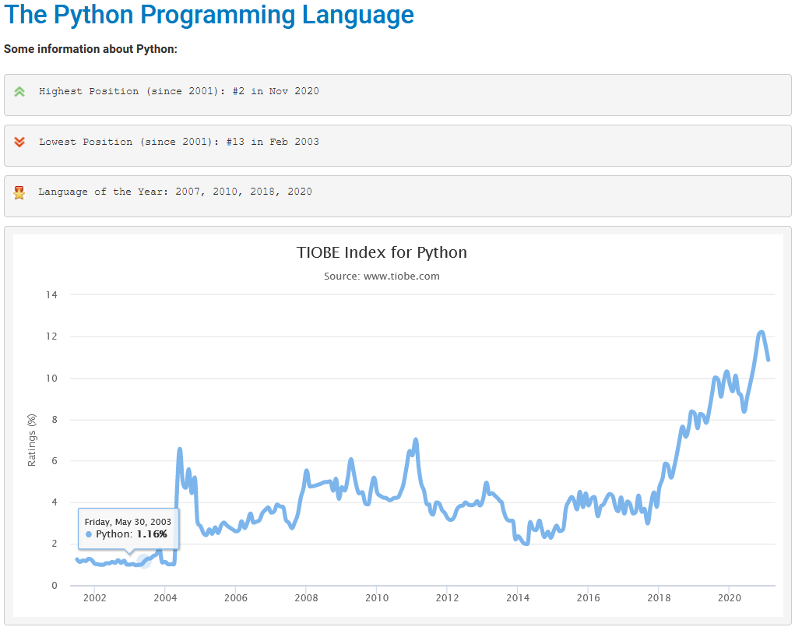

<https://www.tiobe.com/tiobe-index/python/>

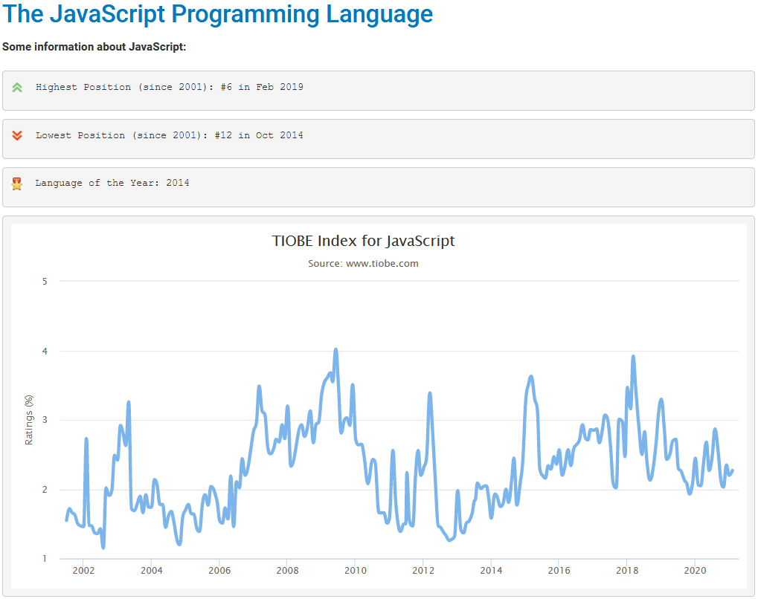

<https://www.tiobe.com/tiobe-index/javascript/>

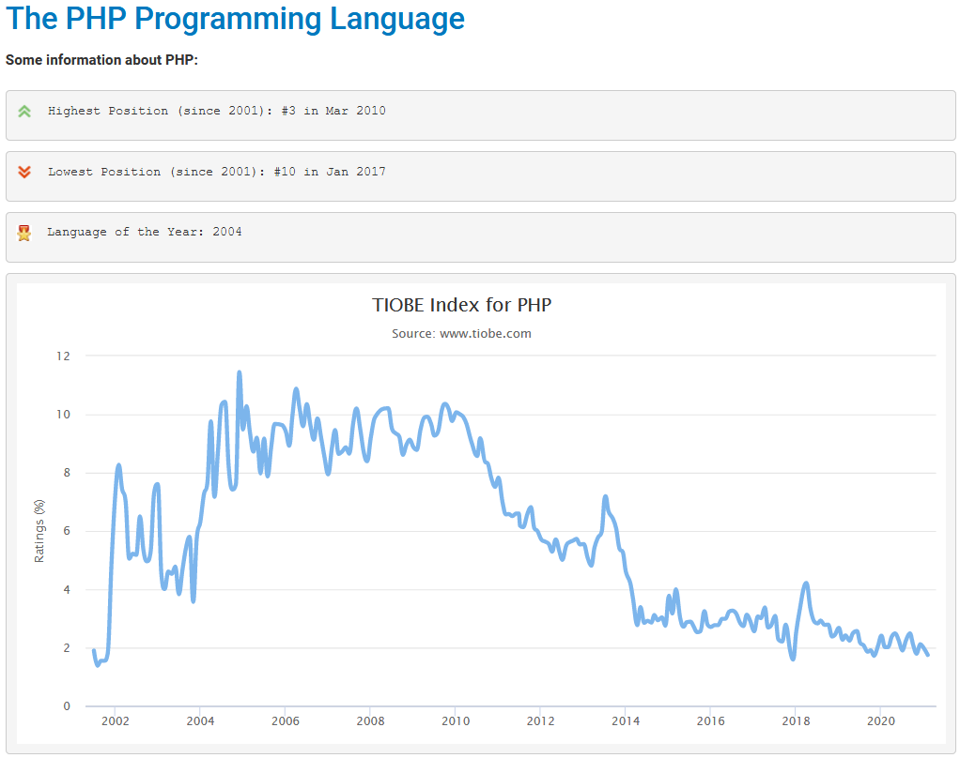

<https://www.tiobe.com/tiobe-index/php/>

Evolution dans le temps

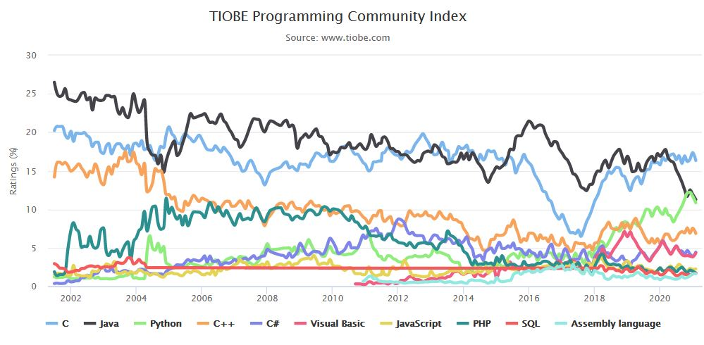

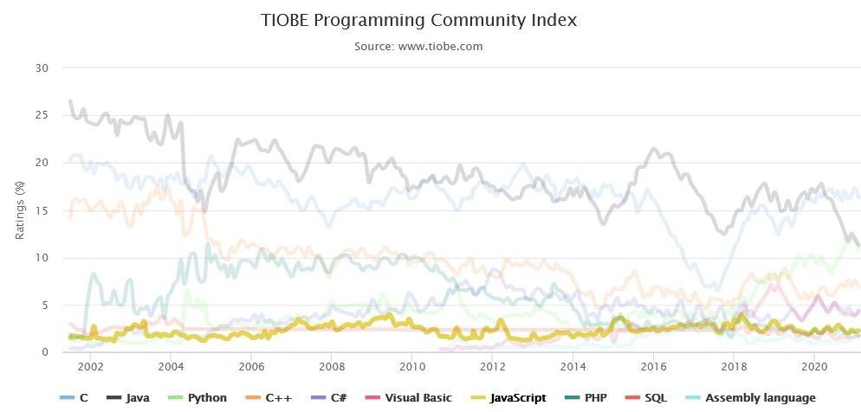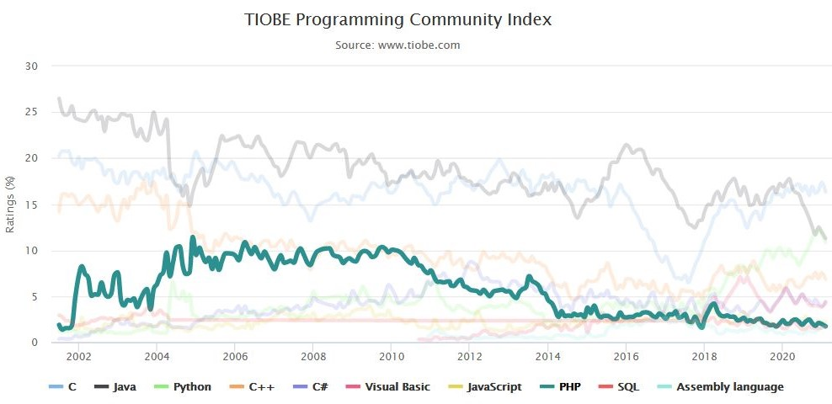

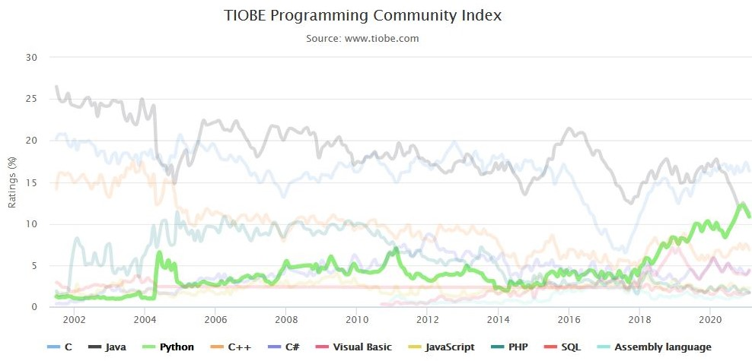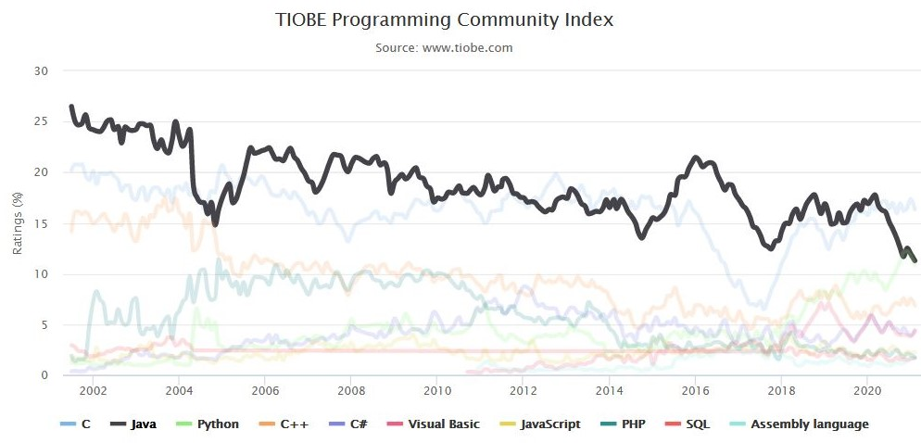

Evolution Historique

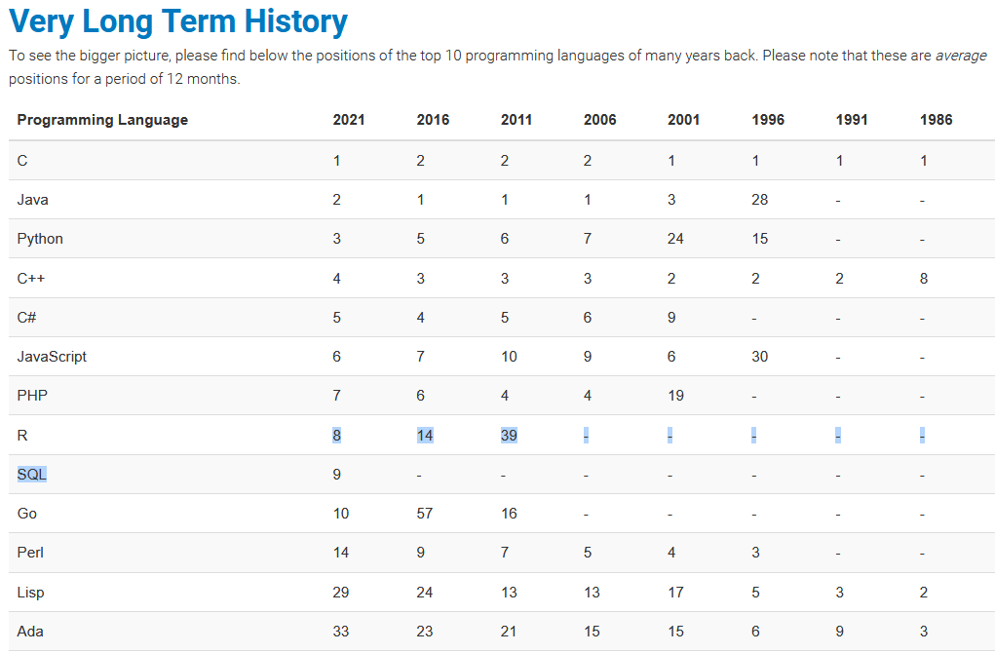

**Programming Language Hall of Fame**

The hall of fame listing all "Programming Language of the Year" award winners is shown below. The award is given to the programming language that has the highest rise in ratings in a year.

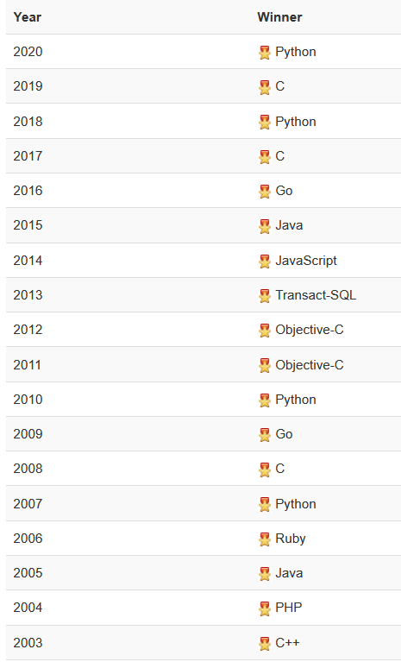

Python => programming language of the year award! => La 4eme fois, ce qui est un record, correspond au langage qui a eu le gain le plus important de popularité Python made a positive jump of 2.01% in 2020. Programming language C++ is a very close runner up with an increase of 1.99%

It has been stated before: Python is popping up everywhere. It started as a competitor of Perl to write scripts for system administrators a long time ago. Nowadays it is the favorite language in fields such as data science and machine learning, but it is also used for web development and back-end programming and growing into the mobile application domain and even in (larger) embedded systems. The main reasons for this massive adoption are the ease of learning the language and its high productivity. These two qualities are key in a world that is craving for more developers in all kinds of fields. Python already tested the second position some months ago and it will for sure swap places with Java permanently soon. Will Python also beat C? Well, C has still one trump card to play: its performance, and this will remain the case for some time to come. So I guess it will certainly take some years for Python to become the new number 1 in the TIOBE index.

The TIOBE Programming Community index is an indicator of the popularity of programming languages. The index is updated once a month. The ratings are based on the number of skilled engineers world-wide, courses and third party vendors. Popular search engines such as Google, Bing, Yahoo!, Wikipedia, Amazon, YouTube and Baidu are used to calculate the ratings. It is important to note that the TIOBE index is not about the *best* programming language or the language in which *most lines of code* have been written.

**The PYPL PopularitY of Programming Language**

The PYPL PopularitY of Programming Language Index is created by analyzing how often language tutorials are searched on Google.

The more a language tutorial is searched, the more popular the language is assumed to be. It is a leading indicator. The raw data comes from Google Trends.

If you believe in collective wisdom, the PYPL Popularity of Programming Language index can help you decide which language to study, or which one to use in a new software project

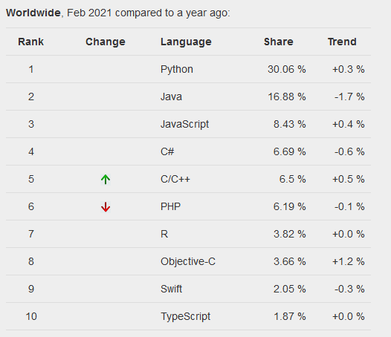

© Pierre Carbonnelle, 2020

<https://pypl.github.io/PYPL.html>

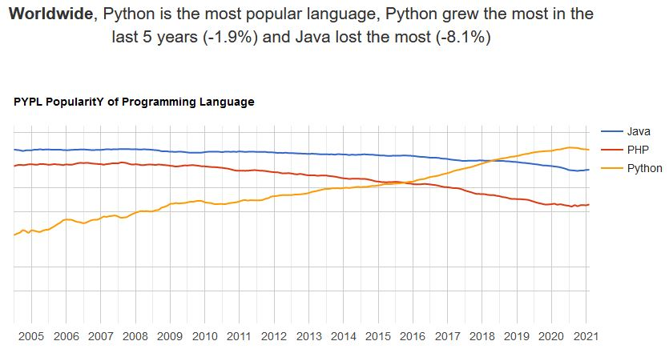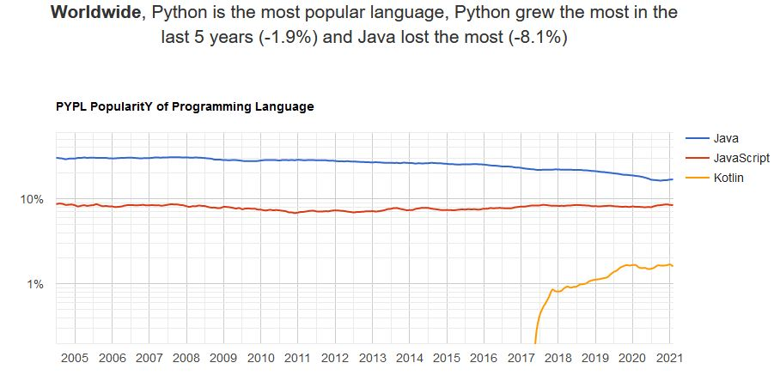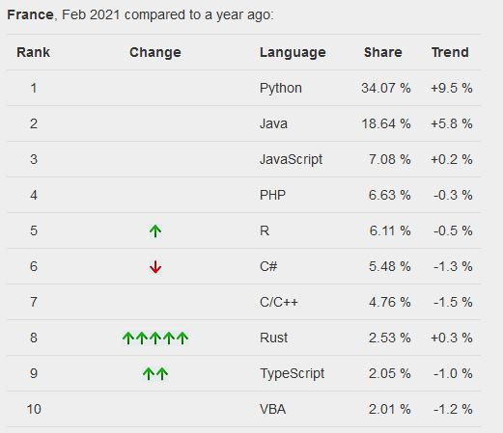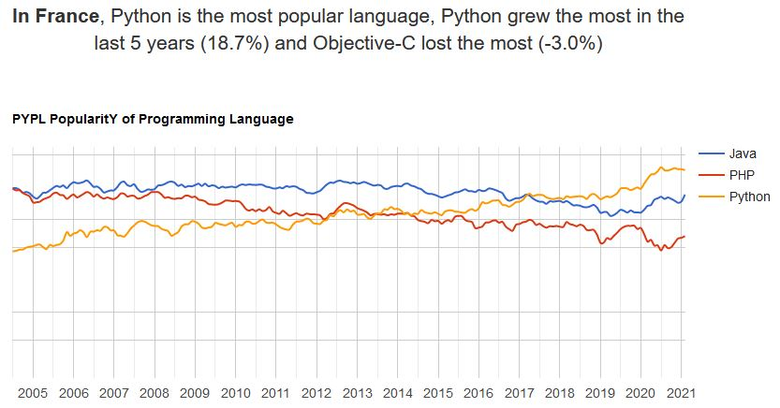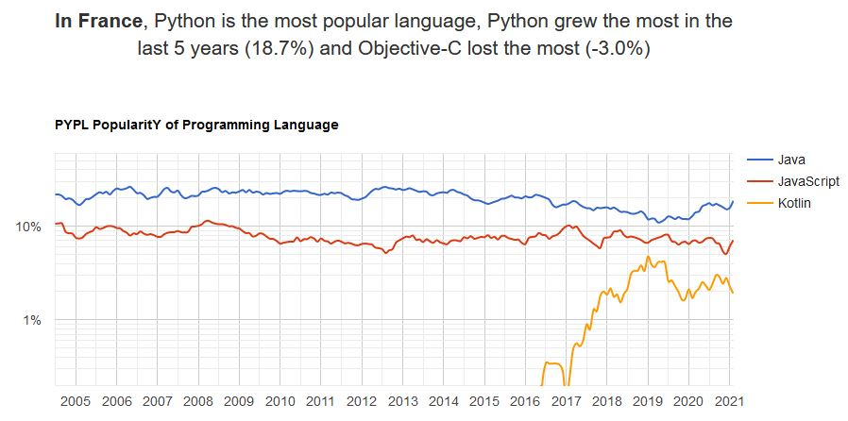

Idée de mise en forme pour les langagues

<http://statisticstimes.com/tech/top-computer-languages.php>

Google trends

Python/php/java : <https://trends.google.com/trends/explore?q=%2Fm%2F05z1_,java,php>

React/vue/angular : https://trends.google.com/trends/explore?q=%2Fm%2F012l1vxv,%2Fg%2F11c0vmgx5d,%2Fg%2F11c6w0ddw9

A voir : https://www.maximelb.com/quel-framework-pour-developper-une-application-mobile-en-2020/

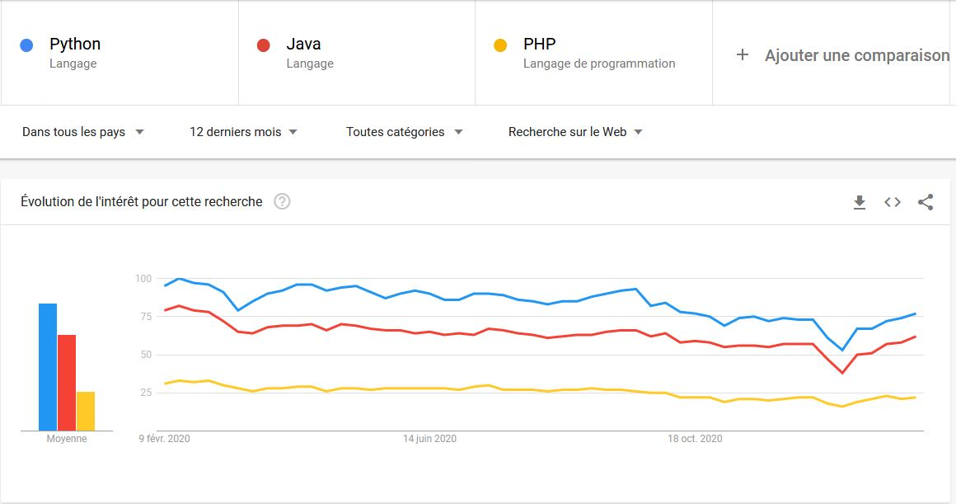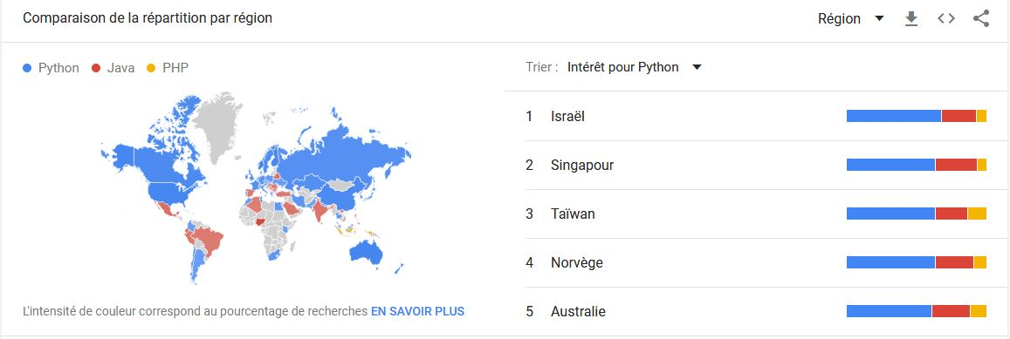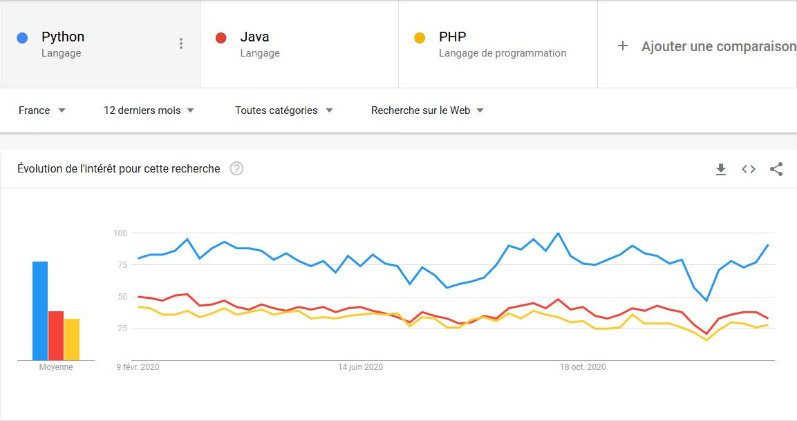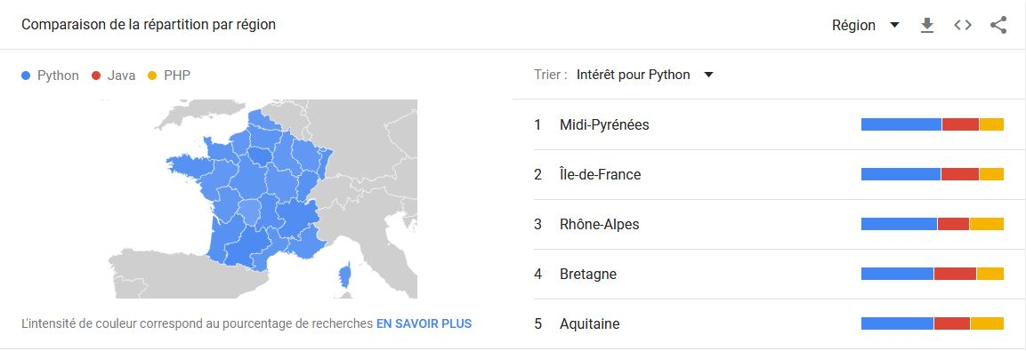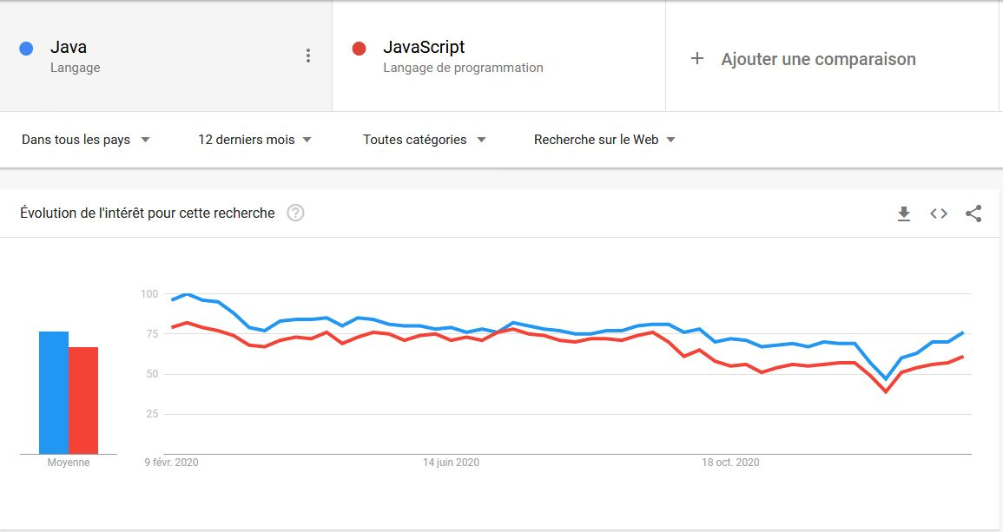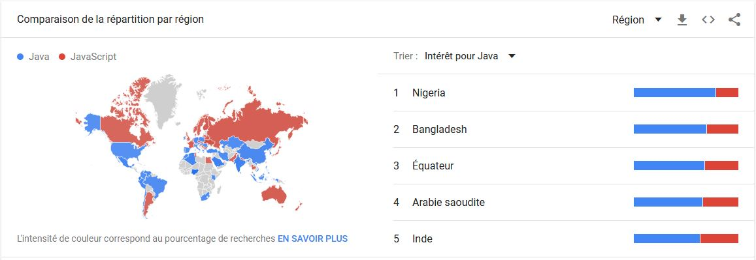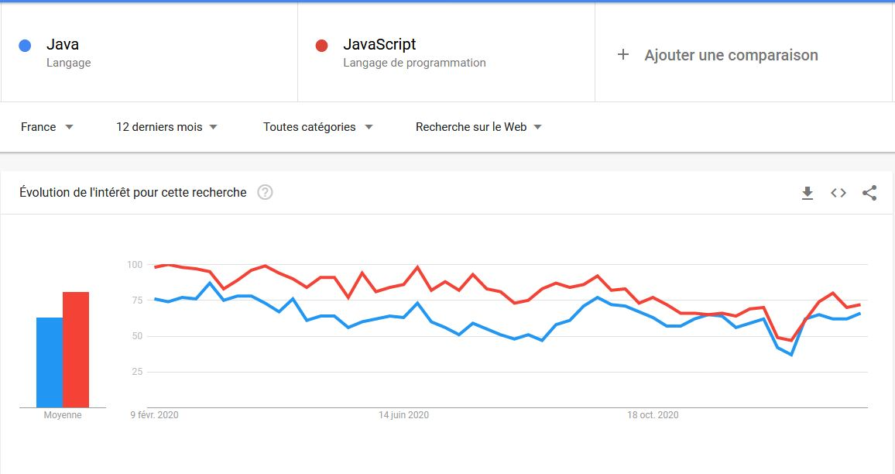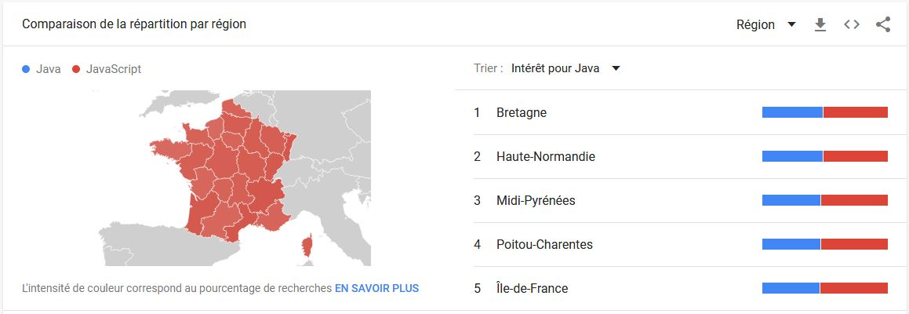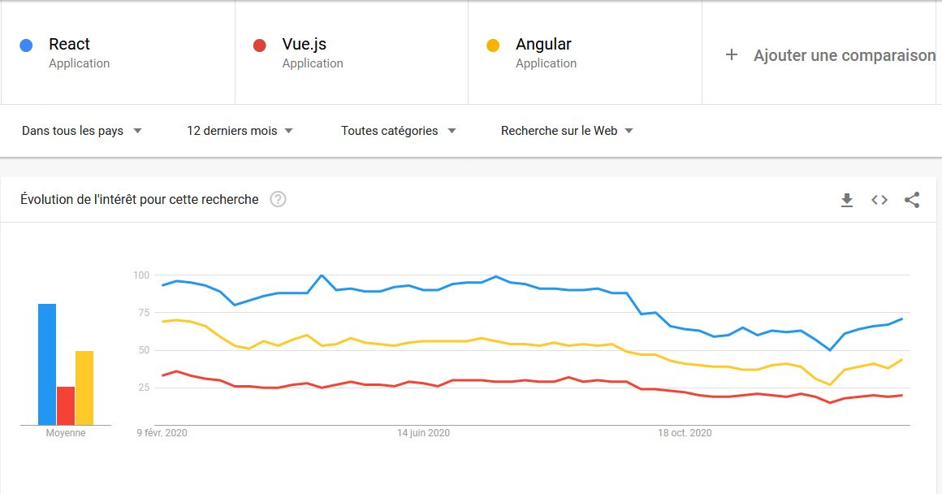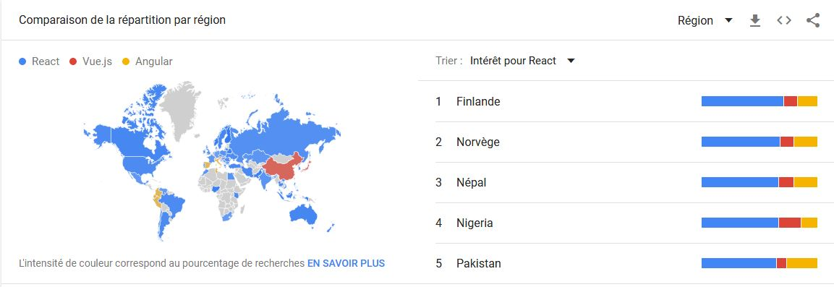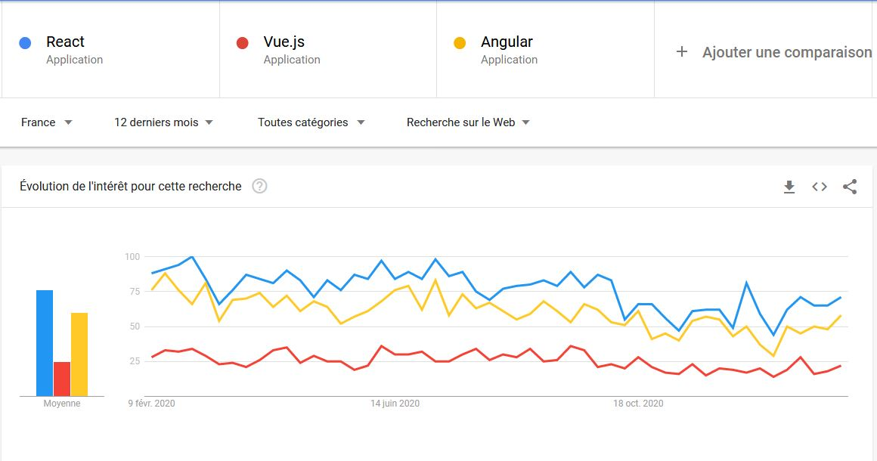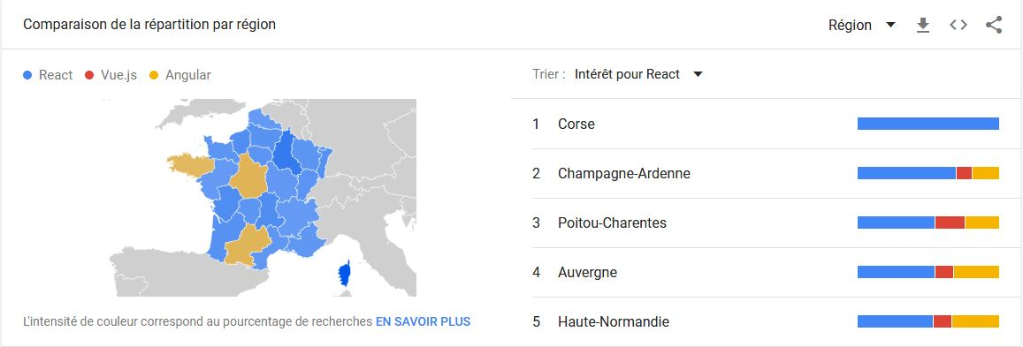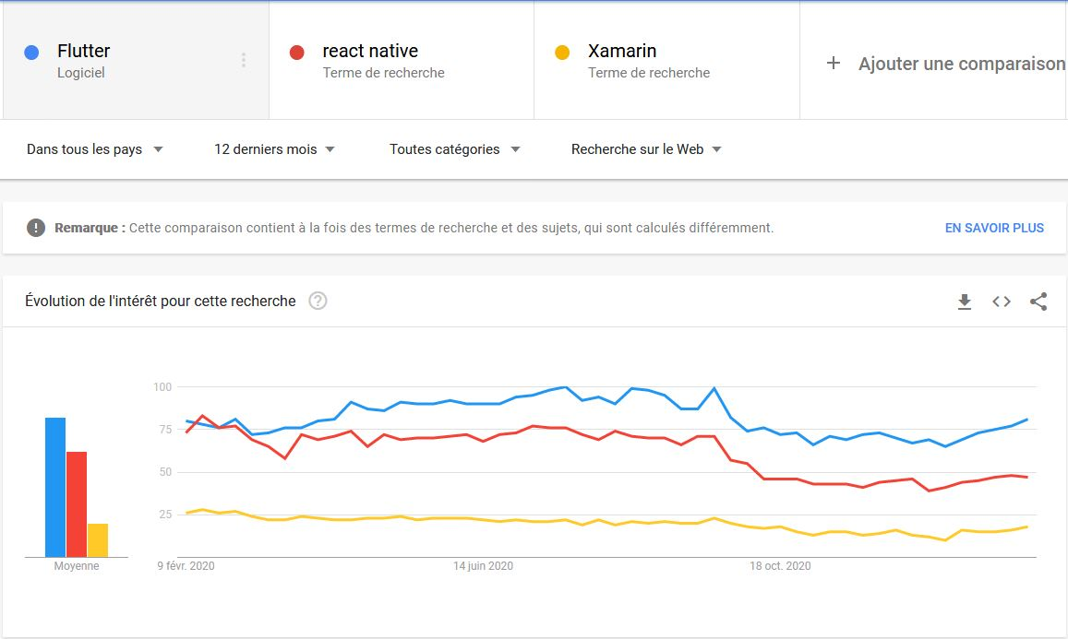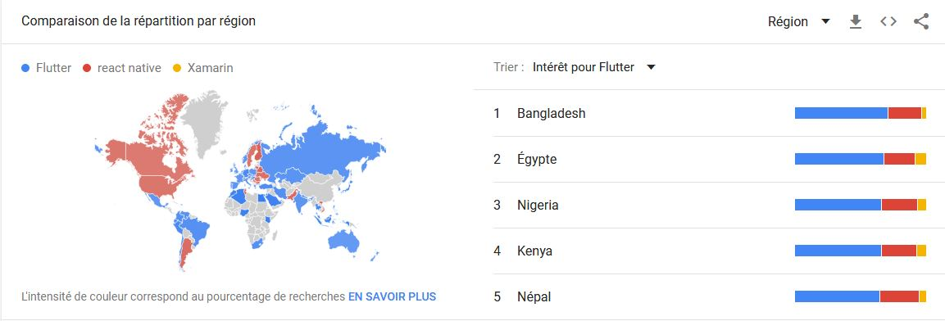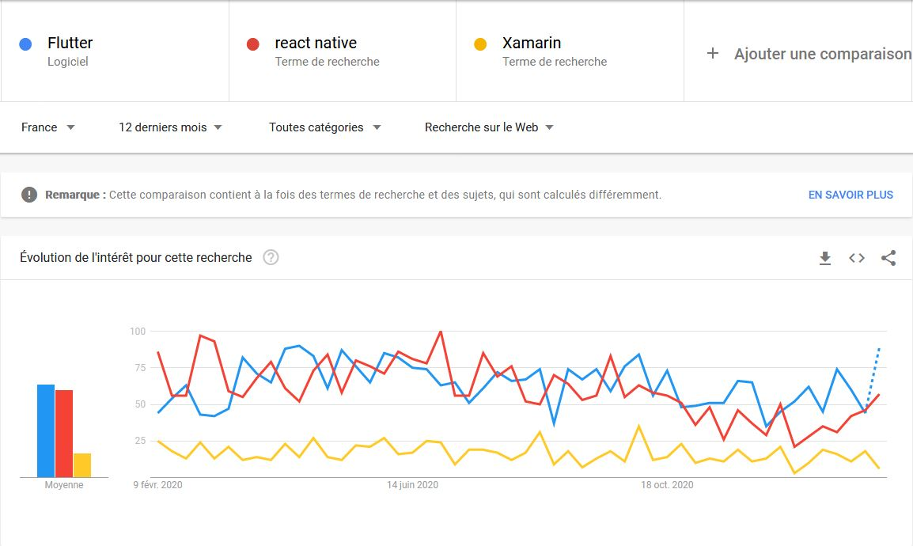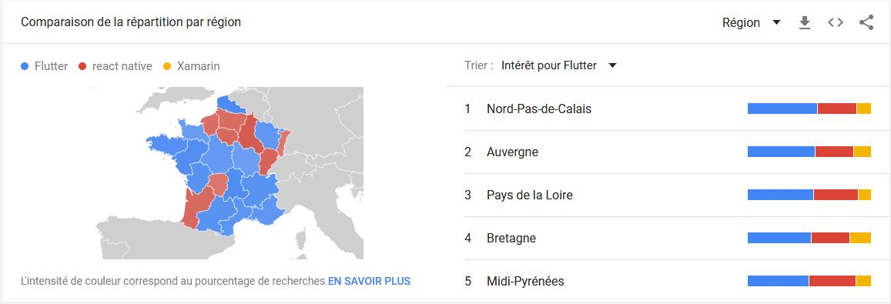

<https://www.npmtrends.com/react-vs-@angular/core-vs-vue>

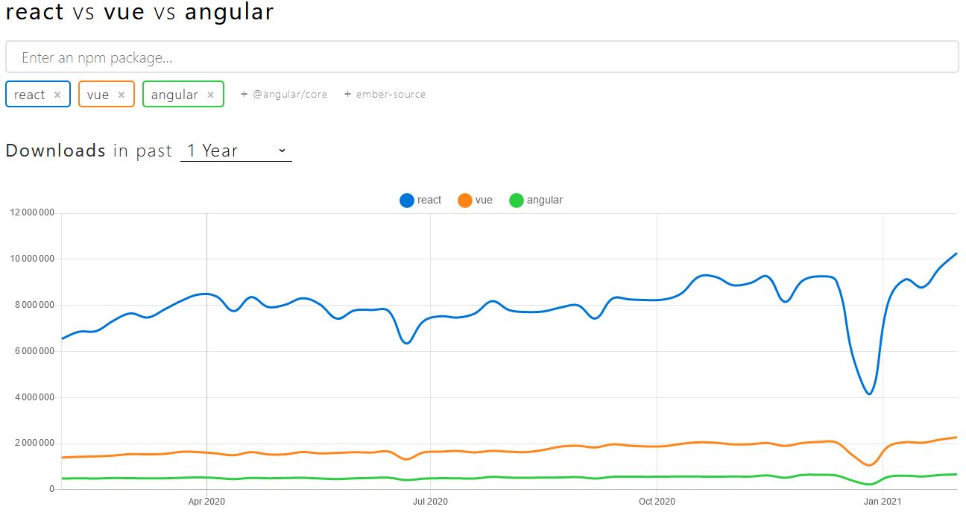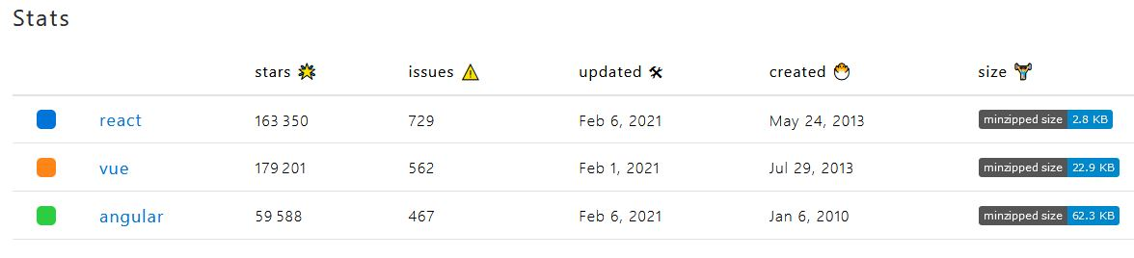

<https://blog.dyma.fr/quel-framework-choisir-en-2020-angular-vue-js-ou-react/>

https://www.codeur.com/blog/choisir-framework-javascript/

<https://dev.to/jessicabennett/react-native-still-a-profitable-choice-in-2019-5km>

<https://www.easypartner.fr/blog/pourquoi-utiliser-react-native/>

https://blog.dyma.fr/quel-framework-choisir-en-2020-angular-vue-js-ou-react/